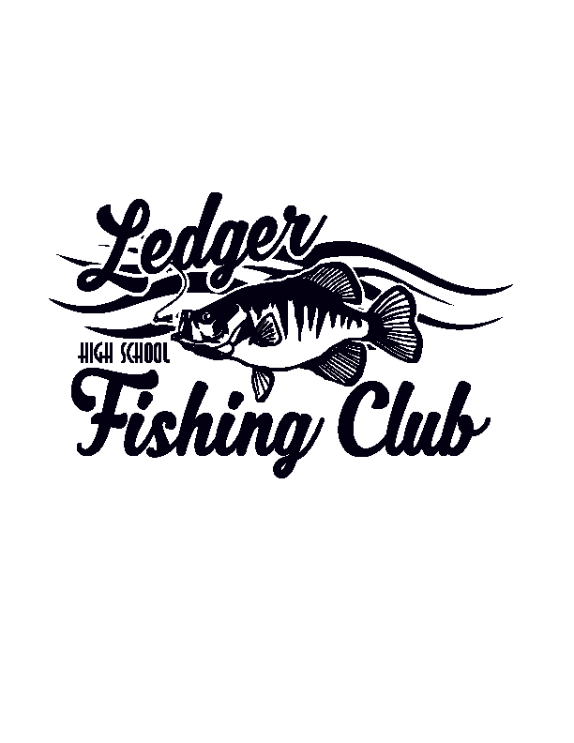

Ledger Fishing Club New Member Meeting
Who: All New Members & Parents
When: Wednesday – November 6th @ 5:00pm
Where: Fisherman’s Road Clubhouse
4047 Fisherman’s Road
Fond du Lac, WI 54937

Students and parents who are interested in learning more about the Ledger Fishing Club are invited to stop in for our 2024-2025 New Member Meeting. The 5:00pm meeting will be tailored towards new/prospective members and their parents. This is an informational meeting where we plan to cover participation requirements, tentative schedule, goals & expectations as well as provide an open forum to answer any questions. Any high school student attending St. Mary’s Springs Academy can join. Parents of new members are highly encouraged to attend along with their son/daughter.

If you have questions in advance, please feel free to reach out to any of the coaches.
Scott Sadownikow : 262-483-0294 / wcsmscott@yahoo.com
Tom Huempfner: 920-979-9417 / tomhuempfner@atlasroofing.com
Kyle Krusick: 262-483-6345 / kyle.krusick4@gmail.com
Tim Babler: 920-960-2105 / tim.babler@yahoo.com
Scott Guelig: 920-579-5718 / sgke92@gmail.com

