Eagle Project: Gaga Ball Pit
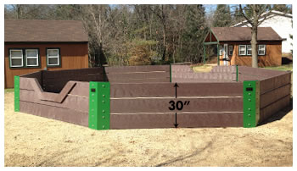
Gaga Ball, an elimination-style game aimed at being the last player remaining in the arena
Where: SMSA upper playground
When: This Spring
What: Hexagon, 14ft diameter, 2.5ft tall, composite wood
How: 2 - 18 players bump a kickball, if you get hit below the knee, you’re out. Last one standing wins!
Who: Volunteers led by Gavin T, SMSA Sophomore
Why: Kids love Gaga Ball! 😊

