Tuesday, November 16, 2021

Hello SMSA Families,

Start your Christmas season off with a fun-filled afternoon! This year the
SMSA Parent Connectors group will be hosting The LedgerExpress: A Christmas Celebration on Sunday, December 5, from 1:00 pm-2:30 pm. The event will be held in Baker Gym & the Commons Area.

Wear your pajamas or dress in holiday gear, enjoy a cup of hot chocolate, make a Christmas craft, take pictures at our photo station, decorate a sweet treat & play some holiday games.

Please send in your RSVP by Tuesday, November 23, 2021, to reserve your LedgerExpress ticket. We hope to see you there!

If you have any questions, please feel free to contact Andrea Nuss, alnuss@charter.net.
______________________________________________________________

“The LedgerExpress: A Christmas Celebration” ticket is $7 per child; adults are free. Please send in your reservation form and money to school by Tuesday, November 23, 2021. Checks may be made payable to SMSA.

Please list the name(s) of the child(ren) attending.

Child 1: ____________________________________

Child 2: ____________________________________

Child 3: ____________________________________

Child 4: ____________________________________

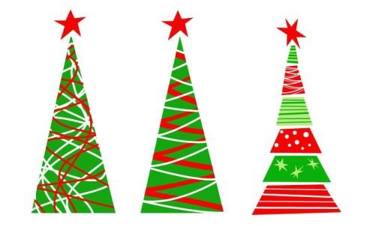
# of adults attending ________

