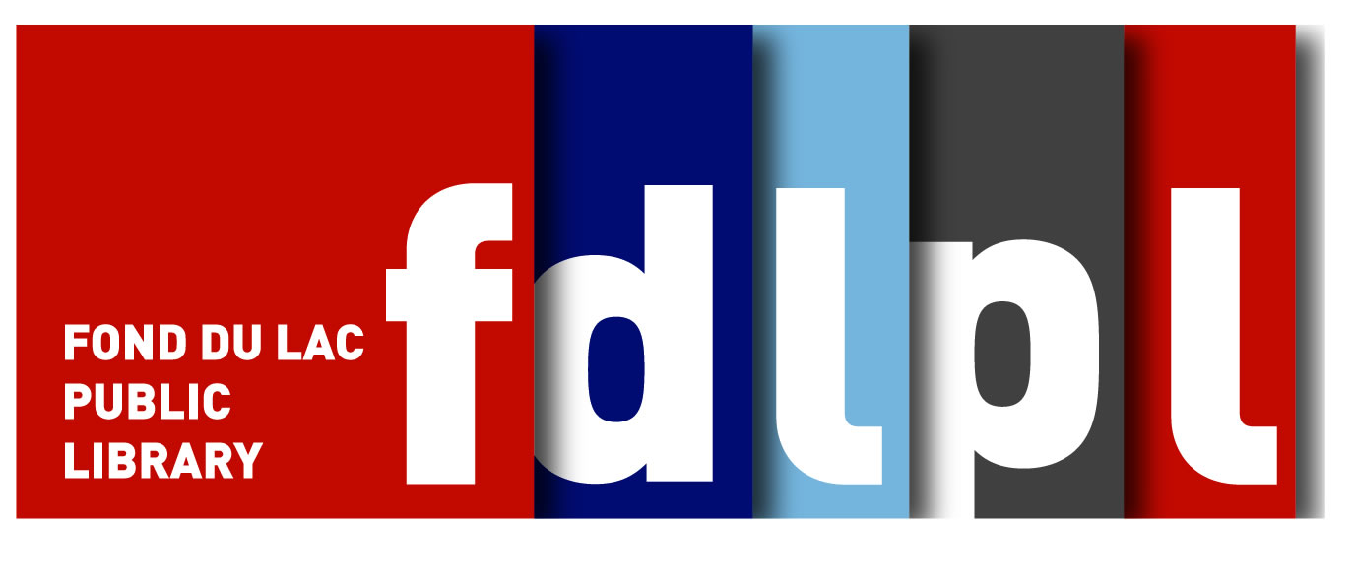

April 28, 2021

FOR IMMEDIATE RELEASE Contact: Ian Stepleton
Public Relations
Fond du Lac Public Library
32 Sheboygan St.
Fond du Lac, WI 54935 (920) 322-3951
stepleton@fdlpl.org
WITH SUMMER READING @ THE LIBRARY LOGO

Summer Reading at FDLPL just a few weeks away

Ready to enjoy the warm rays of the summer sun? Grab a book from the Fond du Lac Public Library as you soak up those rays and start earning prizes through FDLPL’s annual Summer Reading Program.
Starting June 1, the Fond du Lac Public Library will invite users of all ages to “Color Your World,” the theme of Summer Reading @ FDLPL 2021. Through Aug. 15, kids, teens, and adults may read their favorite books to earn prizes and have a little fun.
New for 2021 is an online logging option. Users can use the Fond du Lac Public Library’s online portal, Beanstack, to record their minutes of reading. A link to Beanstack will be available at fdlpl.org starting June 1. Prefer to record minutes on paper? Stop by the Fond du Lac Public Library starting June 1 to get a paper card to record your progress.
Whether recording on paper or online, participation is easy, and earns participants instant rewards along the way as well as a chance at a grand prize at the end of the summer. All reading counts, and reading aloud counts for both the reader and the listener.
Be sure to keep logging those minutes all summer; if the community can reach 2 million minutes read, the Fond du Lac Public Library will unveil a special prize for the community in August.
Fond du Lac Public Library operates two locations: the Main Library at 32 Sheboygan St. in downtown Fond du Lac, and FDLPL Express at 1132 E. Johnson St. near Festival Foods. Starting May 1, the main library is open daily, including the introduction of Summer Sundays: Monday through Thursday from 9 a.m. to 8 p.m., Friday from 9 a.m. to 6 p.m., Saturday from 9 a.m. to 4 p.m., and Sunday from noon to 4 p.m. Chapter 52 Bookstore also will be open its full hours starting May 1: Monday through Wednesday from 2 to 6 p.m., and Saturdays from 9 a.m. to 1 p.m.at 52 Sheboygan St.
For more information about any of these locations or Summer Reading, visit fdlpl.org.

