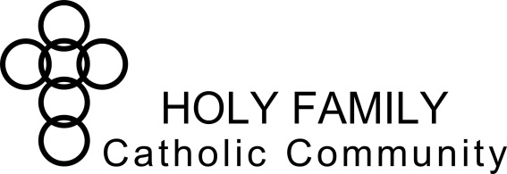
Dear Parents,
This is a very special sacramental year for your child. Please take some time to read the following information in regards to Sacramental Preparation in the Fall and Spring of this year.
What Is It?
At this time in your child’s life, they will begin to understand and experience two immensely meaningful and fulfilling sacraments: First Reconciliation and First Communion. Your child will begin to have a more developed understanding of Christ’s sacrifice and therefore a deeper connection and personal relationship with God. At this time, the Church extends an invitation to them that will allow them to participate in self-reflection through First Reconciliation in the Fall. In the Spring, they will experience spiritual nourishment through First Eucharist.
I want you to know that I am here to help you through each step in this process. In order to make sure your child is well prepared to begin Sacramental Preparation, it is essential that they have previously received the sacrament of Baptism. Additionally, in order for a child to receive the sacraments, it is necessary that at least one parent is Catholic. If you are interested in entering the Catholic faith, or you would like to have your child baptized, please contact Sabina Carter, Director of Christian Formation at scarter@hffdl.org.
The On-going Process
The Sacramental Preparation Program will begin with First Reconciliation at the end of September. Before the first, and every meeting continuously throughout the year, reminders will be placed in the e-Ledger: please make it a priority to check the e-Ledger to ensure that you do not miss any of these important meetings. These meetings will also be advertised in the Holy Family bulletin, which will be available either at Mass or online. Another resource available on the Holy Family website is the Sacramental Preparation calendar.
As the calendar shows, there are a series of family meetings and parent only meetings for the sacrament of Reconciliation in the months of September through December. This is because the sacrament of Reconciliation is a prerequisite for the sacrament of First Communion. Then, in the months of January through April the process begins again with meetings for First Communion. In April, rehearsals are held for each specific Mass the week before the celebration of the sacrament.
Please remember that the last day to register is October 10 and no late registrations will be accepted. The form will be removed from the website at the end of the day on October 10 so if you attempt to register after that, you will be advised that you will have to wait until next year. This program is online registration only so please visit our website for the link and the calendar.
If you have any questions or concerns, please feel free to contact me. I look forward to helping you and your child through this exciting time.
Amanda Cords
Elementary/Middle Formation Coordinator
acords@hffdl.org
(920) 921-0580 ext. 133

