Physical Science: Velocity Graphs Name ________________________
Mod _____ Date _____________

Purpose: The purpose of this activity is to describe the motion of a person using a velocity graph.

Materials: Ultrasonic Motion Detector Colored Pencils

- Using a colored pencil, predict the graph shape that is produced when a volunteer remains at rest in front of the motion detector.
  - Once demonstrated, draw in the actual graph in a different color.
Key:
Prediction:
Actual:

- Using a colored pencil, predict the graph shape that is produced when a volunteer walks:
  - Away from the motion detector at a slow constant speed.
  - Away from the motion detector at a faster constant speed.
  - Once demonstrated, draw in the actual graph in a different color.
Key:
Prediction:
Actual:

- Using a different colored pencil for each , predict the graph shape that is produced when a volunteer walks:
  - toward the motion detector at a slow constant speed.
  - toward the motion detector at a faster constant speed.
  - Once demonstrated, draw in the actual graph in a different color.
Key:
Prediction:
Actual:
- Using a different colored pencil for each , predict the graph shape that is produced when a volunteer walks:
  - toward the motion detector at a steadily slows down (decreases speed).
  - toward the motion detector at a steadily speeds up (increases speed).
  - Once demonstrated, draw in the actual graph in a different color.
Key:
Prediction:
Actual:

- Using a different colored pencil for each , predict the graph shape that is produced when a volunteer walks:
  - away from the motion detector at a steadily slows down (decreases speed).
  - away from the motion detector at a steadily speeds up (increases speed).
  - Once demonstrated, draw in the actual graph in a different color.
Key:
Prediction:
Actual:
- Provide a written description of how a person must move to match each segment.

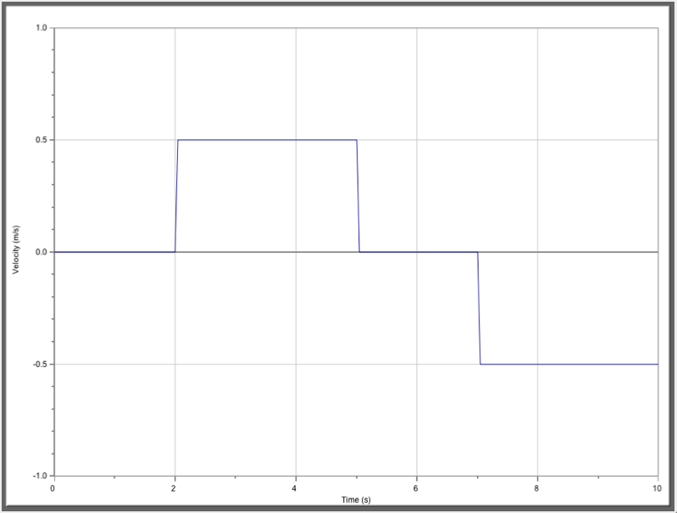

Provide a written description of how a person must move to match each segment.

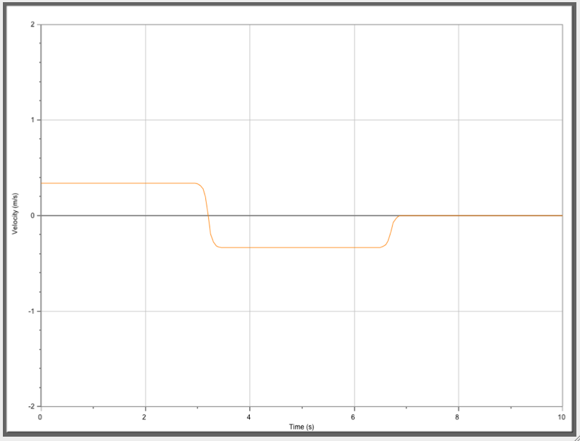

Provide a written description of how a person must move to match each segment.

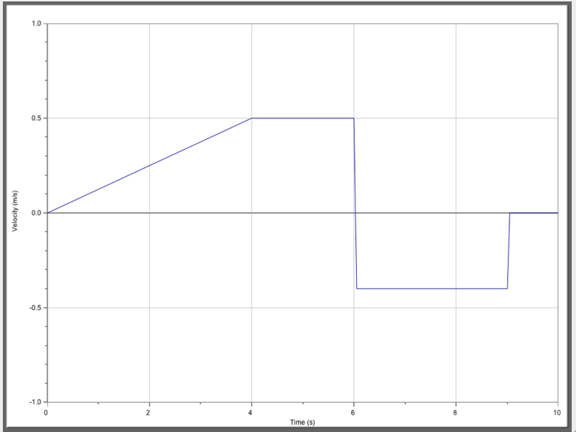

Provide a written description of how a person must move to match each segment.

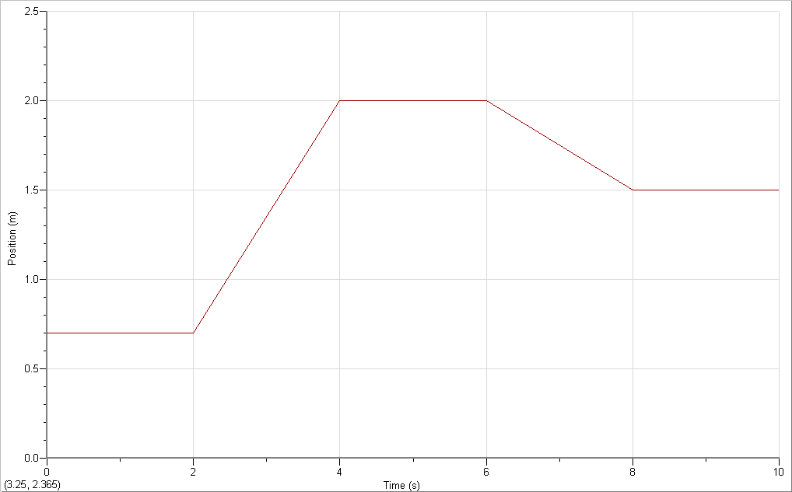
A
B
C
D
E

Velocity (m/s)

Summarizing:
- The slope (or steepness) on a position graph indicates the _____________.
- The slope (or steepness) on a velocity graph indicates the _____________.
  - A positive velocity (+v) means the objective is moving ________ _________ the detector.
  - A negative velocity (-v) means the objective is moving __________________ the detector
- A horizontal line on a velocity graph indicates ____________________________.

Questions: Use complete sentences to answer the questions that follow.
- A graph showing constant velocity would be described as _______________________

- What is the difference between velocity graph of a person walking toward the detector and one walking away from the detector?

- What is the difference between the velocity graph of a person walking slowly toward the detector and one walking faster toward the detector?

