Physical Science: Position – Time graph: Non linear motion

Name ________________________
Mod _____ Date _____________

Purpose: The purpose of this activity is to describe the motion of a person using a position graph.

Materials: Ultrasonic Motion Detector Colored Pencils

- Using a colored pencil, predict the graph shape that is produced when a volunteer walks away from the detector and steadily slows down (decreases speed).
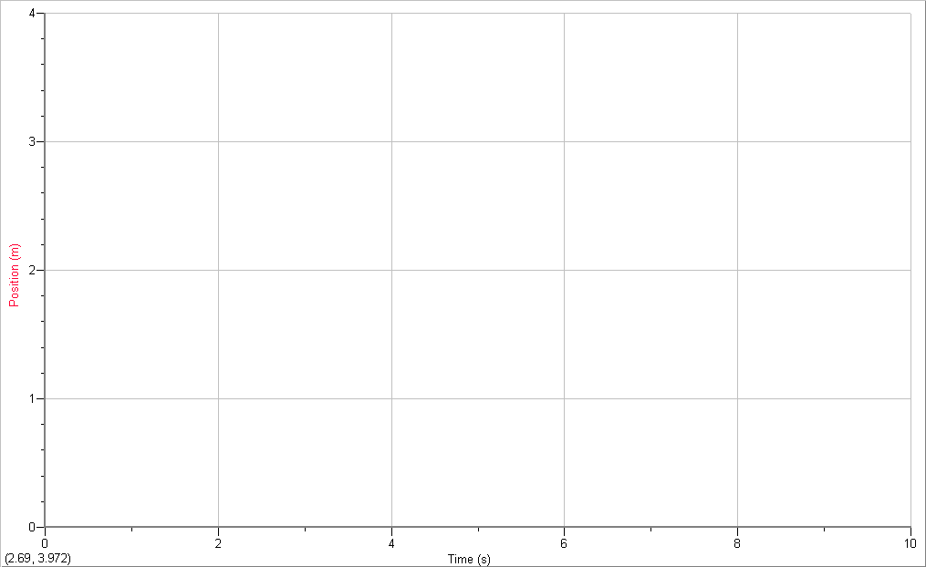
  - Once demonstrated, draw in the actual graph in a different color.
Key:
Prediction:
Actual:

- Using a colored pencil, predict the graph shape that is produced when a volunteer walks away from the detector and steadily speeds up (increases speed).
  - Once demonstrated, draw in the actual graph in a different color.
Key:
Prediction:
Actual:

- Using a different colored pencil for each , predict the graph shape that is produced when a volunteer walks:
  - toward the motion detector at a steadily slows down (decreases speed).
  - toward the motion detector at a steadily speeds up (increases speed).

  - Once demonstrated, draw in the actual graph in a different color. Use the Label A and B to identify each graph.

Summarizing:
- The slope (or steepness) of the position graph indicates the _____________.
  - Changing slope means ________________ ______________________.
  - A position graph with a changing slope is said to be _________________________.
- An increasing slope indicates ___________________ ___________________.
- A decreasing slope indicates ___________________ ___________________.
- A change in velocity during a time interval is known as _______________________.

Provide a written description of how a person must move for each segment.
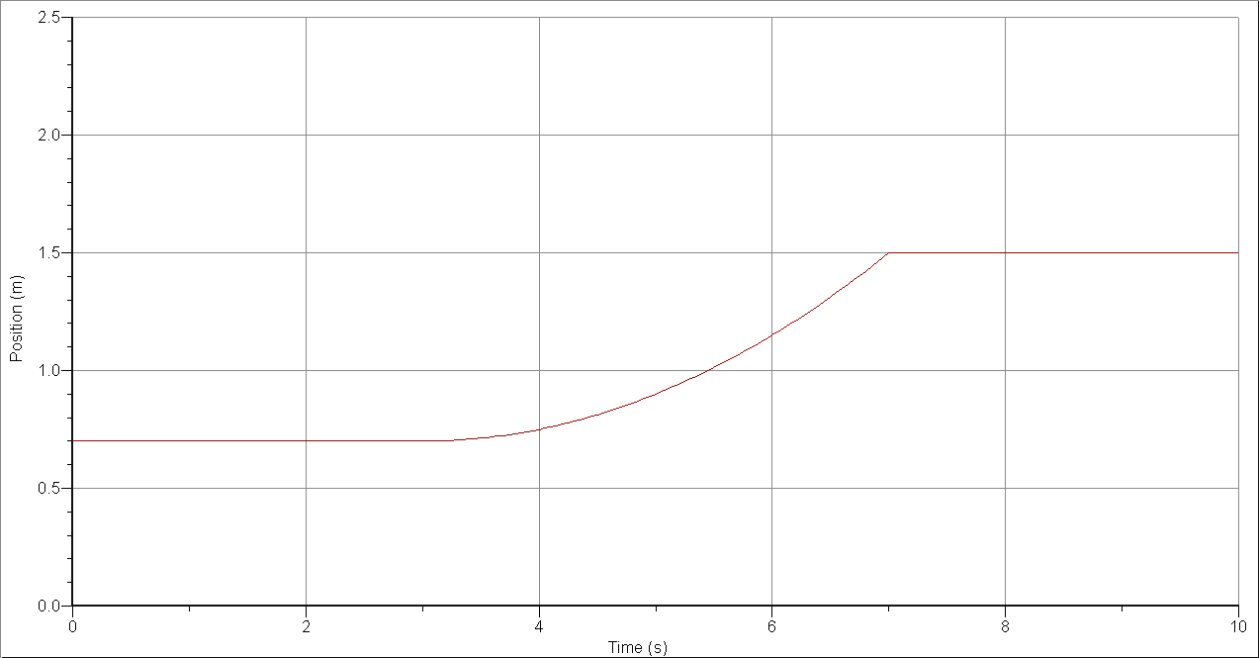
A
B
C

Provide a written description of how a person must move for each segment.

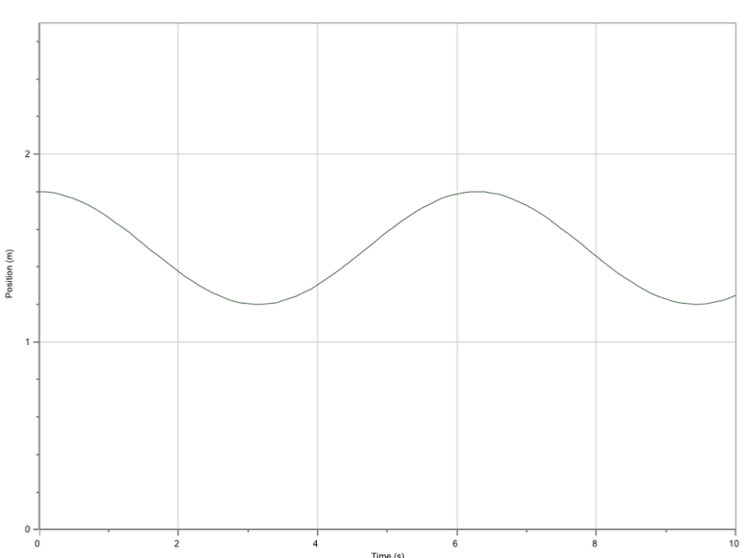

Provide a written description of how a person must move for each segment.
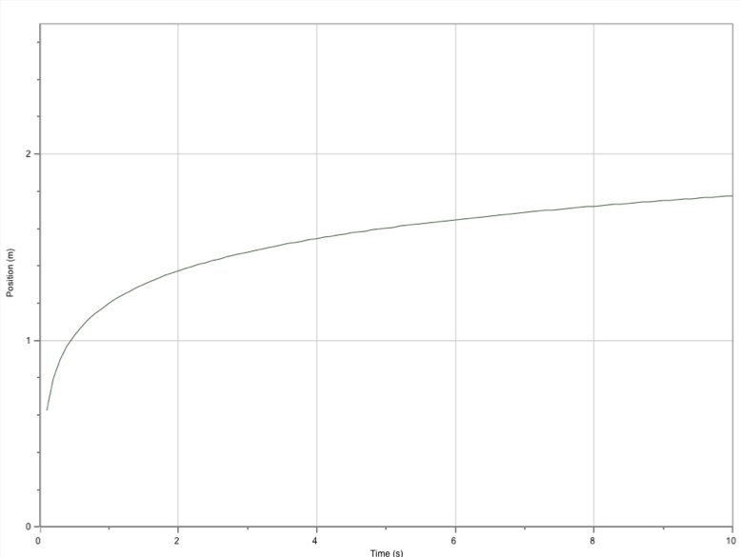

Questions: Use complete sentences to answer the questions that follow.
      - A nonlinear position graph means the object is ________________________.

      - What is the difference between a position graph showing increasing velocity and one showing decreasing velocity?

      - Draw the following position graphs.
  - Constant velocity away from the detector.
d
t

  - Increasing velocity away from the detector. c. Decreasing velocity towards the detector.

d
t
d
t

