LABPRO LAB: Position-Time Graphs: Constant Speed Name ________________________
Mod _____ Date _____________

Purpose: The purpose of this activity is to describe the motion of a person using a position graph.

Materials: Ultrasonic Motion Detector Colored Pencils

- Using a colored pencil, predict the graph shape that is produced when a volunteer remains at rest in front of the motion detector.
  - Once demonstrated, draw in the actual graph in a different color.
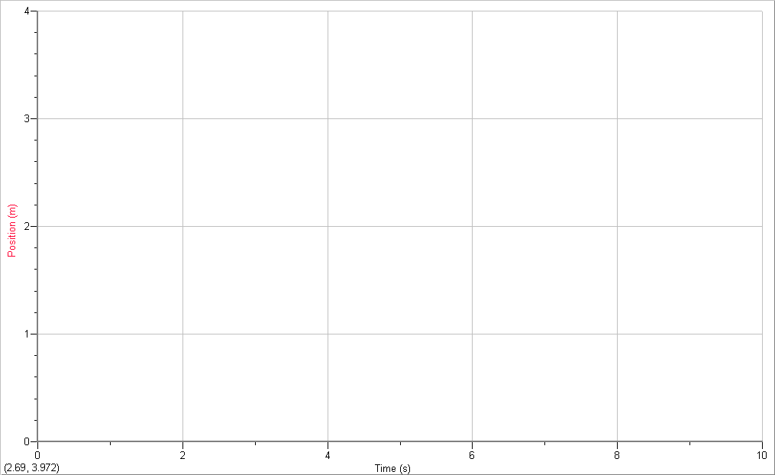
Key:
Prediction:
Actual:

- Using a colored pencil, predict the graph shape that is produced when a volunteer walks away from the motion detector at a slow constant speed. (Don’t worry about the exact numbers—it is the shape of the graph that we are interested in.)
  - Once demonstrated, draw in the actual graph in a different color.
Key:
Prediction:
Actual:

- Using a colored pencil, predict the graph shape that is produced when a volunteer walks away from the motion detector at a faster constant speed. (Don’t worry about the exact numbers—it is the shape of the graph that we are interested in.)
  - Once demonstrated, draw in the actual graph in a different color.
Key:
Prediction:
Actual:

- Using a different colored pencil for each, predict the graph shape that is produced when a volunteer walks toward the motion detector at a slow constant speed.
  - Once demonstrated, draw in the actual graph in a different color.
Key:
Prediction:
Actual:

- 5. Using a different colored pencil for each, predict the graph shape that is produced when a volunteer walks toward the motion detector at a fast constant speed.
  - Once demonstrated, draw in the actual graph in a different color.
Key:
Prediction:
Actual:

- Provide a written description of how a person must move for each segment. (Match 1)

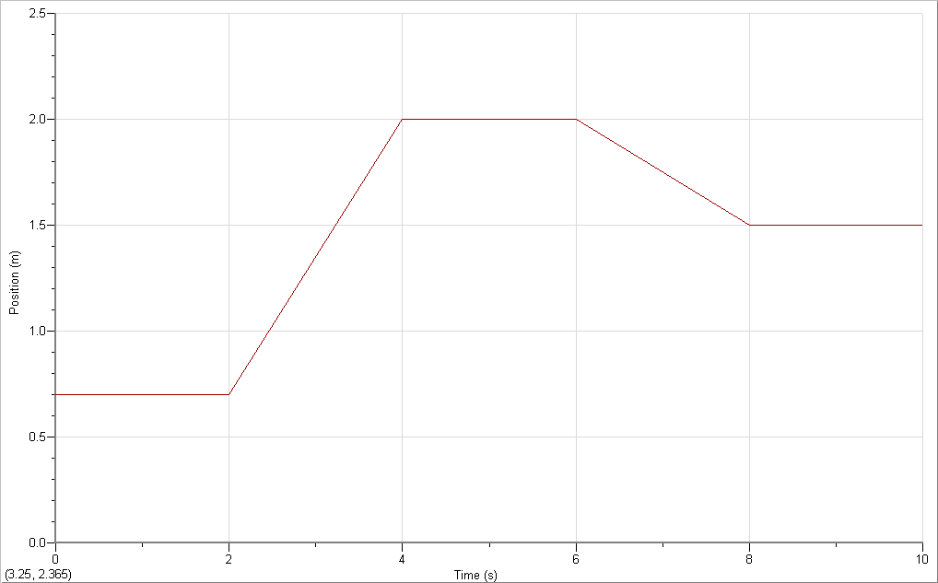
A
B
C
D
E

Summarizing:
- The slope (or steepness) indicates the _____________.
  - Constant slope means constant _______________.
  - The sign on the slope (positive, = or negative, -) indicates the ________________.
- The vertical (y) intercept (or position at t = 0s)) indicates the ___________________.
- The position at the final clockreading indicates the ____________________.
- Displacement (the change in position, Δd) is the ______________ ___________ minus the ______________ ___________.
- Provide a written description of how a person must move for each segment. (Match 5)
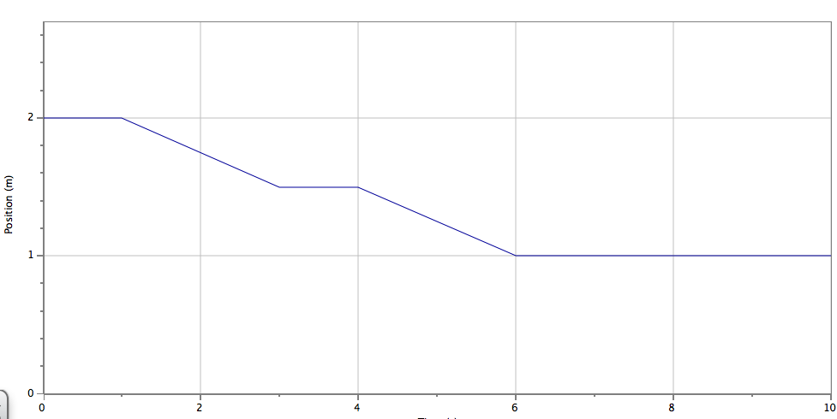

- Provide a written description of how a person must move for each segment. (Match 3)
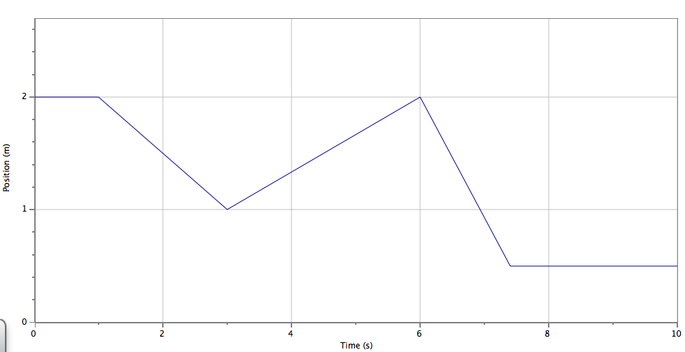

- Provide a written description of how a person must move for each segment. (Match 10)
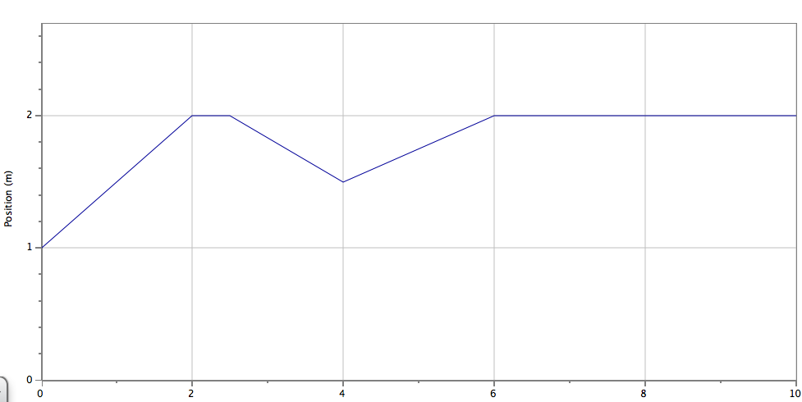

10. Provide a written description of how a person must move for each segment. (Match 4)
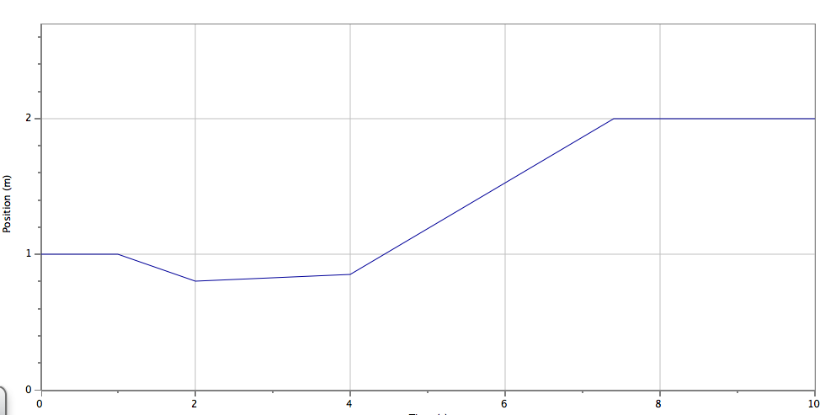

Questions: Use complete sentences to answer the questions that follow.
- A graph showing constant velocity would be described as _______________________

- What does a horizontal (slope = 0) position graph mean

- What is the difference between the graph of a person walking slowly toward the detector and one walking faster toward the detector? (Be sure to use the new terms).

- What is the difference between graph of a person walking toward the detector and one walking away from the detector

